1. These are the components involved in Oauth Framework.  
   So, whenever adopting Oauth Framework, these are the components involved in Authorization and Authentication process.
2. **Components**:
3. 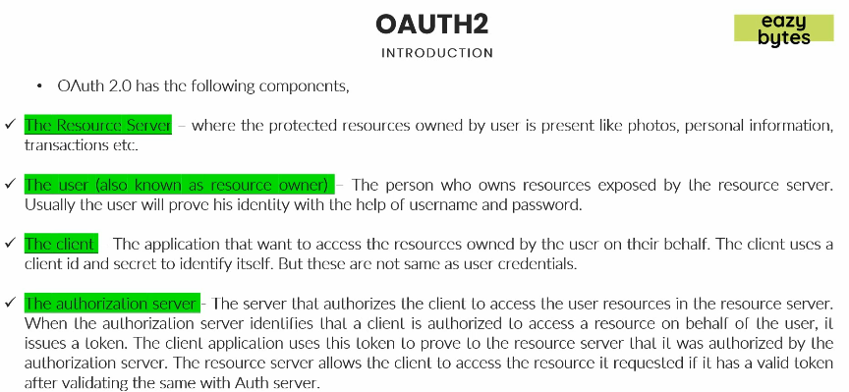
   1. **Authorization Server:**
      1. The component stays isolated and is responsible to validate user authentication and authorization.
      2. Post validating that, it issues a token.
   2. **Resource Server**:
      1. This is the server where all the protected resources of an end user will be stored inside a DB which can be accessed by resource server only.
      2. This resource server will give protected resource to someone only if they provide a valid token.
      3. It will never ask you for username and password (credentials) but for token.
      4. The same token, resource server will validate with authorization server.
      5. In case of no token, it is the responsibility of developer or architect of resource server to detect it and redirect the user to authorization server to perform login operation.
   3. **The User (also known as resource owner)**:
      1. The person who owns the resources exposed by Resource Server.
   4. **The Client**:
      1. The app which wants an access to the protected resources owned by resource owner on behalf of resource owner.  
         Here Twitter Analyser is the client.
4. 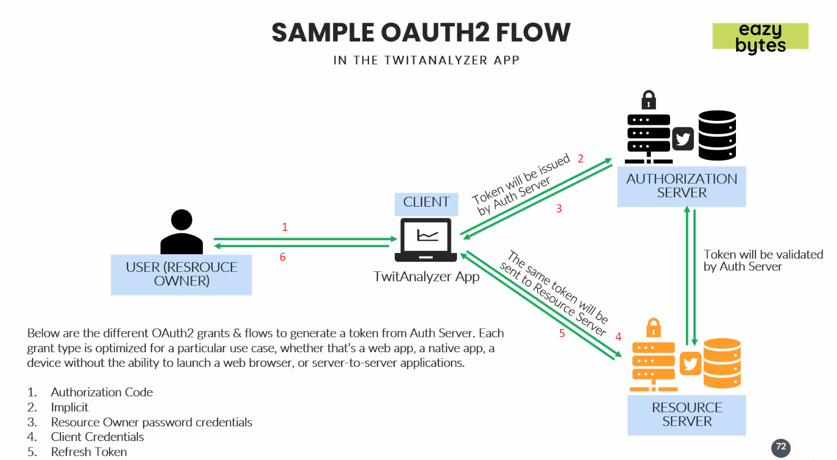
5. Let’s see this in action.
6. 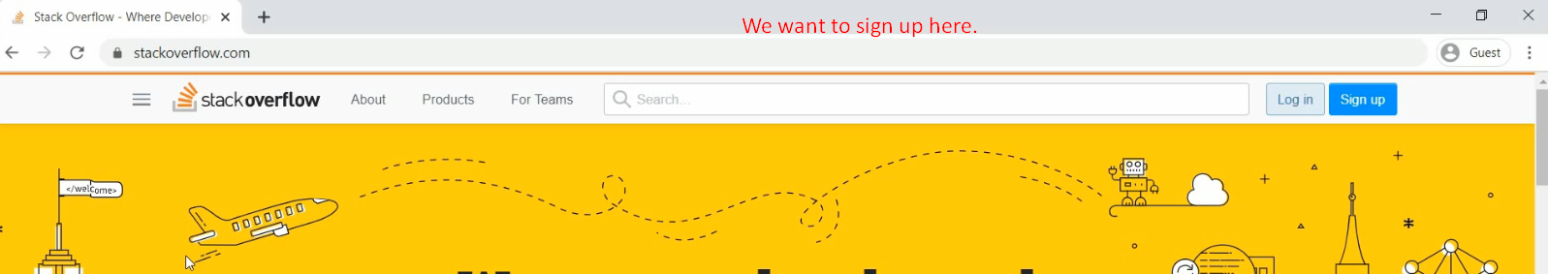
7. 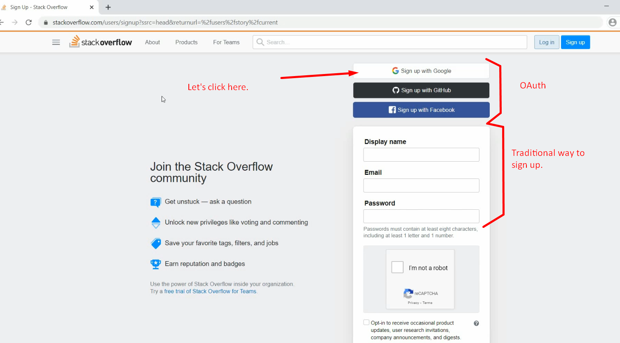
8. 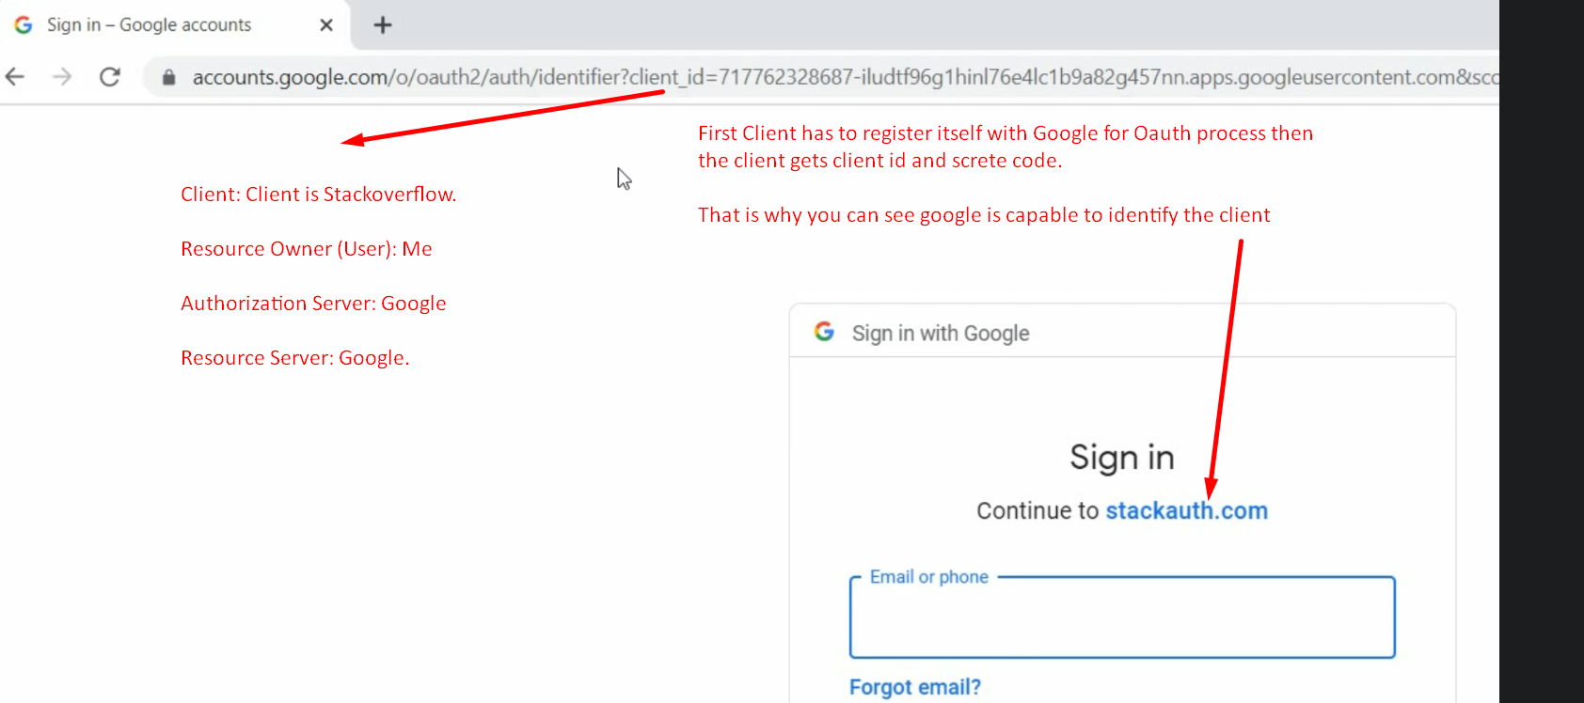
9. 